

Software Engineering Department
Braude College of Engineering
Capstone Project Phase B – 61999

SaferTogether

26-1-D-21

By:
Bar Leibovich
Avner Shimon

Advisor:
Dr. Moshe Sulamy

Link to GitHub:
https://github.com/barleibovich/SaferTogether

Link to Vercel:
https://safer-together.vercel.app

Abstract 4
A. Project Book 4
1. Problem Review and Background 4
2. General Description 5
2.1 System Goals 5
2.2 Target Users 6
2.3 Implemented Scope in Phase B 6
3. Solution Description - Development Track 7
3.1 High-Level Architecture 7
3.2 Package and Deployment Structure 8
3.3 API Request Flow 9
3.4 Alarm and Activity Flow 9
3.5 Backend Implementation 10
3.6 Frontend Implementation 11
3.7 Unity WebGL Implementation 11
3.8 Database Design 12
3.9 Security and Privacy Considerations 12
4. Development Process 13
4.1 Client and Advisor Interface During Development 14
5. Tools and Technologies 15
6. Main Challenges and Solutions 15
7. Results, Conclusions, Metrics, and Lessons Learned 17
7.1 Results 17
7.2 Project Metrics and Goal Coverage 17
7.3 Conclusions 18
7.4 Lessons Learned 18
8. Future Improvements 19
9. References 20
Appendix 2.1 - User Guide 21
How to use SaferTogether 21
1. User Requirements 22
2. Creating an Account 22
3. Logging In 23
4. Administrator: Creating a Group 23
5. Member: Joining a Group 24
6. Administrator: Approving Join Requests 24
7. Saving Alert Location 24
8. Editing an Avatar 25
9. Administrator: Creating Activities 25
10. Starting a Training Alarm 25
11. Real Alarm Flow 26
12. Emergency Screen 26
13. Game Page 27
14. Statistics Page 27
Appendix 2.2 - Maintenance Guide 29
Maintainer setup and operation 29
1. System Requirements for Local Development 31
2. Repository Structure 31
3. Local Installation 31
4. Environment Variables 32
5. Database Setup Procedure 33
6. Local Server Operation 34
7. Deployment Operation 34
8. Monitoring and Backup 34
9. Regular Maintenance Procedures 34
10. Unity Build Maintenance 34
11. Verification and Testing Process 35
12. Main API Endpoints Authentication 35
Groups 36
Drills and alarms 36
Activities and statistics 37
Home Front Command, presence, and push 38
13. Main Data Entities 38
14. Screen Reference 39

Abstract
SaferTogether is a family and group emergency-preparedness system designed for situations in which civilians must enter a protected room quickly, confirm that everyone is safe, and remain calm during the required waiting period. The system focuses on the Israeli civil-defense context, where alerts can arrive suddenly and the first minutes after an alarm often include uncertainty, stress, and unstructured waiting.
The implemented Phase B prototype combines a mobile-first web application, a Node.js gateway, a Supabase database, browser push notifications, Home Front Command alert checks, Unity WebGL mini-games, telemetry collection, statistics, and optional AI-generated summaries. The system does not replace official alert applications. Instead, it supports the post-alert workflow: coordinating the group, reducing uncertainty, guiding children through calming activities, and producing a practical post-event report for caregivers or group administrators.

A. Project Book

1. Problem Review and Background
SaferTogether focuses on what happens after an emergency alert. Official systems warn the public and provide safety instructions, but families and groups still need to check whether every member has reached a protected area. This is usually done through phone calls or messages, which can be delayed, repeated, or missed during a stressful situation.
During Phase A, we reviewed emergency applications and found that most of them focus on alerts, instructions, or location sharing. Messaging applications allow users to report that they are safe, but they do not provide a clear group view showing who has confirmed and who has not. SaferTogether does not replace the Home Front Command application. It supports the group after the official warning is received.
The literature reviewed in Phase A showed that emergency situations may cause children fear, uncertainty, and difficulty concentrating. Clear instructions and a structured activity can give children a specific task during the waiting period. Therefore, we decided to include activities designed mainly for children.
The activities are available only after the safety stage. Each member first enters the protected area and confirms that they are safe. The activity is unlocked after all members confirm, or when the administrator decides to continue. Official safety instructions always have priority.
The system includes an emergency-kit puzzle, a door-code memory game, and a missile-avoidance game. These activities are connected to emergency preparation and collect values such as response time, completion time, mistakes, hits, movement, tilt, and device rotation.
These values help administrators compare different drills, but they are behavioral observations only. A slow response or mistake may be caused by stress, distraction, lack of knowledge, or an accidental touch. SaferTogether does not diagnose stress or present the results as medical information.
We identified a gap between receiving an official alert and managing the group during the protected-room period. Existing tools provide warnings or communication, but they do not combine safety confirmation, group progress, child-oriented activities, gameplay measurements, and post-event review. SaferTogether was developed to support this process.

2. General Description
We built SaferTogether as a mobile-first web application because the intended users should be able to open it from a link without installing a native application. The same code also runs on a desktop browser, which is useful for an administrator preparing activities or reviewing results. The interface is in Hebrew and uses separate screens for short tasks rather than placing every option on one dashboard.

There are two user roles. An administrator represents the responsible adult: for example, a parent, teacher, counselor, or group leader. This user creates a group, approves join requests, prepares activities, starts training, monitors confirmations, and examines the report. A regular member represents a child, student, relative, or another participant. This user joins with a code, enters the group, confirms safety, and completes the assigned activity. We hide actions that do not belong to the role, but we also repeat the authorization checks on the server. Hiding a button alone would not prevent a user from sending an API request manually.

Before an event, the administrator creates a group and receives a short join code. A member enters this code and sends a request. We chose an approval step rather than immediate membership because the group contains personal status and result information. The administrator can see the pending username and approve the expected person. The member then appears on the board. Users may also save an alert location and choose an avatar. The avatar editor is an embedded Unity build, while the profile data is stored through the same authenticated backend as the rest of the application.

The group board is the center of the system. It shows the group and its members and provides the administrator with access to activities, pending requests, statistics, training, and the real-alarm workflow. The Home Front Command control displays the current external-alert status when that integration is available. We kept training and real events in the same data model. The mode is stored with the alarm, but confirmation, unlocking, activity submission, and reporting use the same path. This decision reduced duplicate code and makes a drill a meaningful technical test of the real workflow.

During an active event, the interface becomes simpler. The member sees the alarm type, the large safety-confirmation button, and the family or group state. The server records each confirmation only for the active alarm. The activity page checks the server-side unlock status before loading content. This prevents a member from bypassing the intended order by directly opening game.html. After the activity is completed, the result is connected to the member, activity, group, and event run.

2.1 System Goals
SaferTogether is a web-based application with backend services and Unity WebGL modules, designed to help families, classrooms, and small groups stay coordinated during real alerts and training drills. The core idea is simple: every member confirms safety with a single tap, removing the uncertainty that usually follows an alarm. Because real events and drills share the same workflow, running a practice session is a genuine rehearsal of what actually happens during an alert. Once the group is safe, the system unlocks calming activities — trivia questions and Unity mini-games — to keep members, especially children, occupied during the waiting period. Throughout these activities the system records behavioral data: answer timing, wrong attempts, device tilt, and motion. Administrators can review this data in a structured report after the event ends, and optionally request a brief non-clinical summary.

2.2 Target Users
The primary target users are families with children, school classrooms, small educational groups, and community teams. The administrator can be a parent, teacher, counselor, or group leader. Members can be children, students, relatives, or other group participants. The interface is mobile-first because the system is expected to be used from phones during real situations, while desktop use remains supported for administration and testing.

2.3 Implemented Scope in Phase B
The current prototype includes role-based user authentication, group creation and join approval, live group board behavior, training drills, real/training alarm sessions, push notifications, Home Front Command area matching, activity creation, trivia, Unity mission room, avatar editor, telemetry collection, statistics charts, and a Groq-powered situation summary.
Component | Implemented role
SaferTogetherUI | Static web frontend, mobile screens, shared JavaScript, styles, service worker, and Unity embedding.
Gateway | Node.js HTTP server, API route dispatching, static file serving, JSON helpers, and deployment entry behavior.
Services | Business logic for authentication, groups, alarms, activities, analysis, push, presence, and Home Front Command status.
Supabase | Authentication, PostgreSQL tables, profile/group/activity/alarm data, and row-level security policies.
UnityClient | Unity source project for the avatar editor and mission-room mini-games.
Vercel API entry | Serverless deployment entry point that connects hosted API paths to the gateway handler.

3. Solution Description - Development Track

3.1 High-Level Architecture
We divided the project into layers after the first features began to make app.js and the server difficult to reason about. SaferTogetherUI contains the pages that the browser loads, the common stylesheet, the shared application code, the service worker, the sensor and sound helpers, the frontend API modules, and the two deployed Unity builds. Gateway contains the Node HTTP server, the route files, and shared request/response functions. Services contains the business logic and the integrations. Supabase provides authentication and the PostgreSQL database. api/index.js connects the same gateway behavior to Vercel.

A normal request illustrates the separation. When the administrator approves a join request, the click handler does not contact Supabase directly. It calls groupGateway.js in the browser. The shared apiClient adds the current access token and sends JSON to the group route. The route checks the method and input and calls groupService.js. The service resolves the authenticated profile, verifies that the user is allowed to manage the group, performs the database operation, and returns an application result. The HTTP layer converts expected failures into a clear status and message.

We used the same pattern for authentication, groups, alarms, activities, presence, push, and Home Front Command operations. This created more files, but each file has a clearer reason to change. For example, changing the way alert polygons are cached belongs in orefAlertService.js and does not require changing the board page. Changing the layout of the board does not change groupService.js.

The browser never receives private server credentials. The anonymous Supabase key may be used as part of the normal authenticated flow, but the service-role key, the VAPID private key, and the Groq key remain in the server environment. The service layer performs role and membership checks, and the database adds Row-Level Security policies. We considered this double check necessary because the application handles group membership, location association, and behavioral results.

The solution uses a client-server architecture. The browser loads the static web application and Unity WebGL modules. API requests are sent to the Node.js gateway, which delegates work to service modules. The services communicate with Supabase, Home Front Command alert/location data, the Web Push provider, and the Groq API for optional non-clinical administrator summaries.
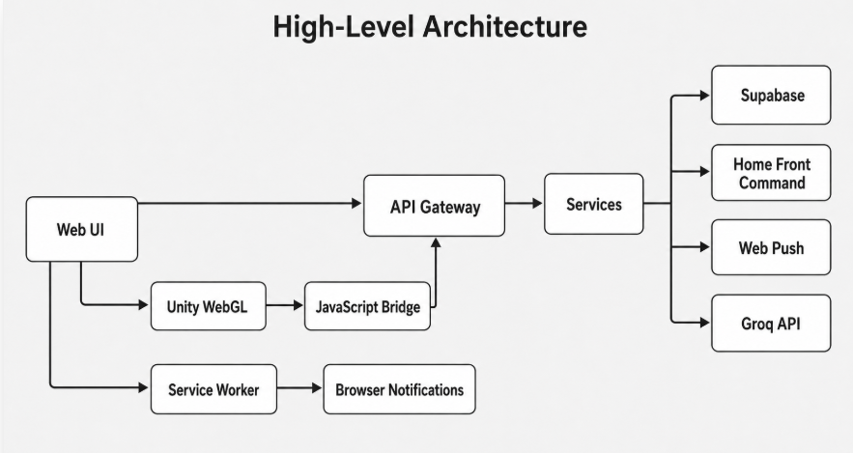
Figure 1. High-level architecture of the SaferTogether prototype.
The browser loads the web interface and the Unity WebGL modules. Authenticated requests pass through the API gateway to the service layer, which communicates with Supabase and the external services. Unity communicates with the web page through a JavaScript bridge, while browser notifications are handled by the service worker.

3.2 Package and Deployment Structure
Layer / Package | Main responsibility
Mobile Browser | HTML pages, app.js, API gateway modules, service worker, motion sensors, and Unity WebGL container.
Gateway | HTTP server, static file server, route dispatcher, and shared request/response helpers.
Services | Auth, group, alarm, activity, analysis, Home Front Command, push, presence, location, Supabase, and configuration services.
External/Data | Supabase Auth, Supabase PostgreSQL, Home Front Command endpoints, Web Push, and Groq API.
Unity | Avatar editor, mission room, puzzle game, door-code game, missile dodge game, and WebGL bridge.

3.3 API Request Flow
1. The browser sends a JSON request to an /api route.
2. Gateway/server.js checks whether the path is an API path.
3. The gateway tries the route handlers for authentication, activities, alarms, presence, push, groups, and Home Front Command status.
4. The selected route reads the JSON body, extracts the access token, and calls the relevant service function.
5. The service validates the user session through Supabase and performs the database or external operation.
6. The route returns JSON or a structured error response.

3.4 Alarm and Activity Flow
The alarm workflow ensures that activities are not opened before the safety stage is completed. The diagram shows the actions performed by the administrator, the member, and the system during a training drill or a real alarm.
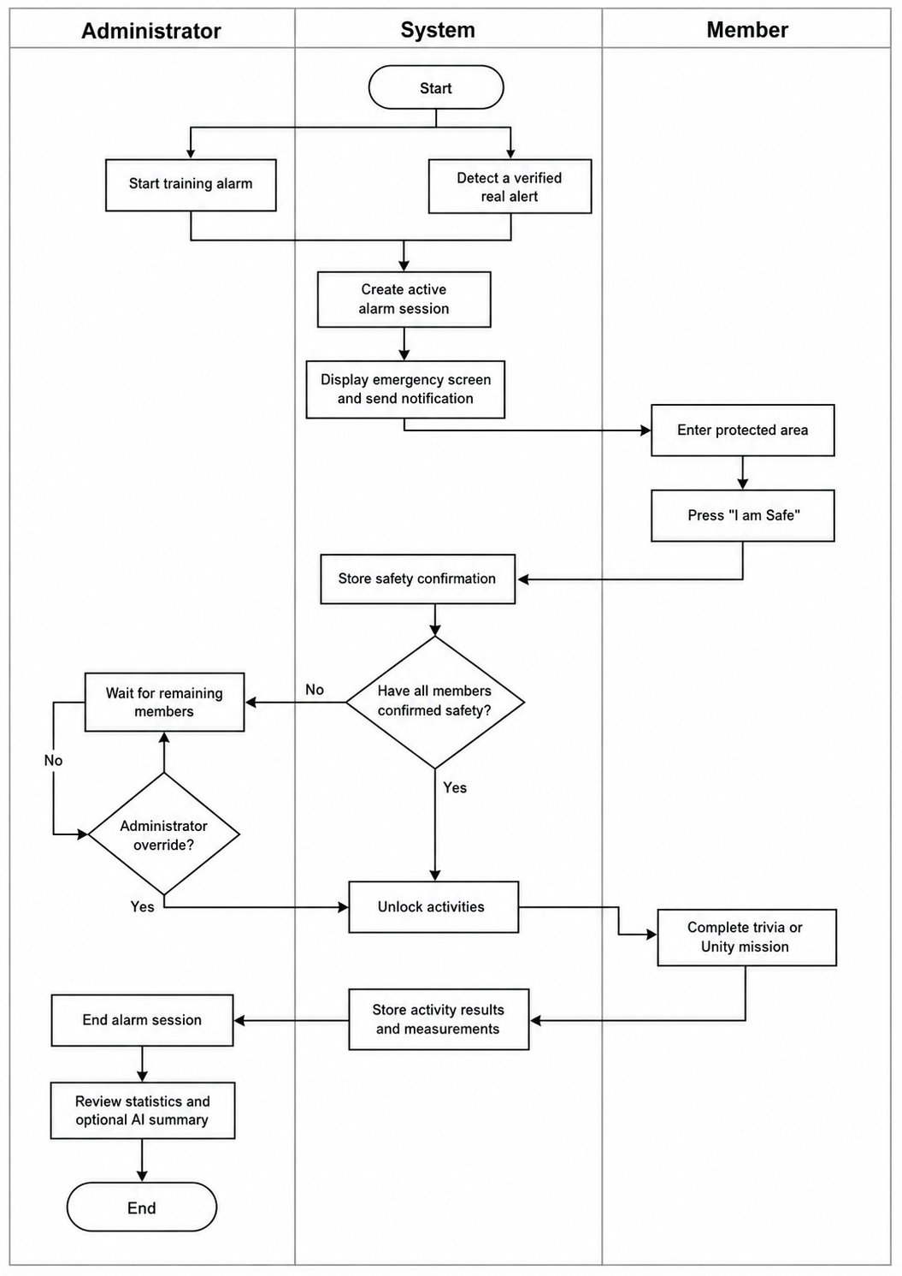
Figure 2. Activity diagram of the alarm, safety-confirmation, activity, and reporting workflow.

3.5 Backend Implementation
The backend is divided into a gateway layer and a service layer. The gateway handles HTTP routing and static files. The service layer contains the business logic and integrations. This separation makes it easier to maintain the system and to change one feature without rewriting the whole application.
File / service | Purpose
Gateway/server.js | Creates the HTTP server, dispatches API routes, and serves frontend files.
authService.js | Handles username-based authentication, profile loading, role handling, avatar updates, credentials, sessions, and alert locations.
groupService.js | Handles group creation, join codes, join approval, membership, group deletion, drills, and safe-state tracking.
alarmService.js | Handles active alarm lifecycle, safe users, unlock state, progress, and idempotent Home Front Command alarm creation.
activityService.js | Handles activity validation, activation, result storage, metric aggregation, review, and statistics bundles.
analysisService.js | Transforms statistics into structured measurements and requests a non-clinical AI summary.
orefAlertService.js | Fetches alerts, location data, polygon maps, coordinate matching, and member alert annotation.
pushService.js | Handles VAPID configuration, push subscriptions, group notifications, and stale endpoint cleanup.

3.6 Frontend Implementation
The frontend is a screen-first mobile web application. Shared logic is stored in SaferTogetherUI/app.js, shared styles in SaferTogetherUI/styles.css, and gateway modules under SaferTogetherUI/src/api. Access and refresh tokens are stored locally so a member can remain logged in and continue receiving alarms across app restarts.
Screen | Role in the workflow
Login and signup | Account creation, login, and role selection.
Groups | Group list, join flow, profile summary, avatar launch, and alert-location setup.
Create group | Administrator group creation.
Board | Group board, members, Home Front Command status, and admin controls.
Emergency | Safe confirmation, locked/unlocked state, and progress monitoring.
Game | Active trivia or Unity mission-room gameplay.
Trivia and missions | Administrator activity creation.
Statistics | Per-member charts, result summaries, and AI summary generation.
Avatar editor | Embedded Unity avatar editor.

3.7 Unity WebGL Implementation
Unity is used for the avatar editor, the missions room and the mini-games. The web page sends Unity a JSON payload containing the selected games and the current activity configuration. During play, each mini-game records its own measurements. When the mission ends, Unity returns one structured JSON result through the JavaScript bridge. The frontend submits this result to the authenticated API, where the backend connects it to the current member, group, activity, alarm mode, and event run.
The system does not calculate a medical stress score. The statistics page groups the stored values by member and run and displays timing, mistakes, hits, movement, tilt, and device rotation when available. The optional Groq summary receives only these selected measurements and is instructed to describe possible patterns carefully without diagnosing stress.
Unity mini-game | Measurements returned
Emergency-kit puzzle | Stage timing, selected item correctness, wrong attempts, and completion state.
Door-code memory game | Sequence length, wrong attempts, weighted score, and time per stage.
Missile dodge game | Total time, missile hits, tilt strength, and movement-related values when available.

3.8 Database Design
Supabase PostgreSQL is the persistent data layer. Row-level security is central to the design: members can read group data relevant to them and submit their own results, while administrators can manage groups, activities, alarm state, and result review.
SQL script | Data / policy area
group_access_policies.sql | Group access policies and membership permissions.
group_activities.sql | Activity definitions, activations, activity results, and RLS.
activity_metrics.sql | Metric aggregates used by statistics and AI summaries.
group_alarms.sql | Active alarm sessions, safe users, live progress, and policies.
group_alarm_oref_raise.sql | Security-definer function for member-raised real alarms after Home Front Command verification.
presence.sql | Profile heartbeat tracking.
profile_locations.sql | Saved Home Front Command alert location per profile.
profile_avatars.sql | Avatar image storage fields and policies.
push_subscriptions.sql | Push endpoint storage and cleanup.

3.9 Security and Privacy Considerations
Security was treated as a cross-cutting concern across every layer of the system. Supabase handles authentication and issues short-lived access tokens; the gateway checks these on every request that touches group data, so no authenticated state is ever assumed.At the database layer, Row-Level Security provides an additional authorization check for requests made with an authenticated user session. The Supabase service-role key can bypass these policies, so it is stored only on the server and is never exposed to the browser. Group information is visible only to members and administrators of that specific group. Creating or activating activities requires an administrator role, and members can only write result rows tied to their own user ID. The AI summary feature receives structured behavioral numbers only, and both the prompt and the result are explicitly framed as non-clinical observations.

4. Development Process
We developed the system as vertical slices rather than completing the entire frontend and only later connecting a backend. For each feature we identified the user action, the data that had to persist, the authorization rule, the service operation, the route, and the visible result. This approach repeatedly exposed problems that a static screen would not show. For example, a group board could look correct for the administrator but still fail when a second account encountered an RLS policy.

The first working slice was authentication and role-based profiles. We then added group creation, short join codes, pending requests, approval, and the group board. Once two users could share a group, we added presence and the alarm lifecycle. Activities came afterward because the safety gate had to exist before a game could be placed correctly in the flow. Trivia gave us a simpler way to establish creation, assignment, activation, result submission, and statistics before connecting the more complex Unity mission room.

Unity integration was developed as a contract between the WebGL build and the page. The browser sends the chosen mission configuration; Unity sends progress and final measurements. We tested the games independently and then tested whether a completed run reached Supabase and appeared for the correct administrator. The avatar editor uses a similar bridge but returns profile visual data rather than activity metrics.

Home Front Command matching, push, sensors, and Groq were added as separate integrations after the basic group flow worked. This order was important. It meant a temporary external failure did not prevent us from testing group membership or training. We also kept optional configuration optional: for example, a missing Groq key disables the text summary but does not prevent statistics from loading.

The GitHub repository served as our shared delivery point. We used the running prototype in advisor demonstrations, then translated feedback into changes in screens, services, database scripts, and documentation. One lesson from this process is that documentation should have been written alongside each completed flow. Reconstructing installation and user steps at the end was harder and initially produced descriptions that were too short and too general.

Phase A defined the problem space and conceptual architecture. Phase B focused on turning the concept into a working web and Unity prototype. Development was performed incrementally: each feature introduced a backend route, service logic, frontend gateway function, UI behavior, and database table or policy when persistent data was required.
Development step | Main result
Authentication and roles | Admin and member login, signup, sessions, and profile loading.
Groups | Group creation, join codes, join requests, and approval workflow.
Board and status | Live group board, member status, presence, and alert location support.
Alarms and drills | Training and real alarm sessions with safe confirmation and unlock flow.
Activities | Trivia and mission activity creation, activation, play flow, and result submission.
Unity integration | Avatar editor and mission-room WebGL builds connected to the web application.
Telemetry and statistics | Metric collection, aggregation, charts, and optional AI summary.
Deployment readiness | Vercel entry point, environment configuration, service worker, and Web Push support.

4.1 Client and Advisor Interface During Development
The main feedback during development came from our project advisor through demonstrations of the working system. In each demonstration, we presented the current user flow, including registration, group management, emergency screens, Unity activities, and the statistics page. The feedback was then converted into specific development tasks and documented in the GitHub repository.
Several important changes were made following these reviews. We corrected Hebrew RTL problems, text that extended outside mobile screens, unclear buttons, and inconsistent login and group status displays. We also redesigned the mission room and replaced the earlier simple activities with the emergency-kit puzzle, door-code memory game, and missile-avoidance game. The avatar system was updated with new characters, clothing options, and movement animations. Later demonstrations focused on the complete two-user flow and on verifying that activity results reached the statistics page correctly

5. Tools and Technologies
Tool / Technology | Use in the project
JavaScript and Node.js | Backend gateway, service logic, and frontend behavior.
Supabase Auth and PostgreSQL | User accounts, sessions, persistent data, and database policies.
Supabase Row-Level Security | Database access control for users, members, and administrators.
Unity and C# | WebGL avatar editor, mission room, and mini-games.
Browser Service Worker and Web Push | Push notification registration and alarm notifications.
Home Front Command data | Alert status, location matching, and group alert annotation.
Groq API | Optional AI-generated administrator summaries.
Vercel | Hosted static frontend and serverless API deployment.
Git and GitHub | Version control and submission folder for deliverables.

6. Main Challenges and Solutions
The hardest product decision was the activity gate. The attractive part of the project is the game, but opening it too soon would contradict the safety goal. Our solution was to make safety confirmation part of the server-controlled event and require an unlock state before game loading. The administrator override remains available because a missing or disconnected device should not necessarily block a supervised drill forever. The tradeoff is visible and deliberate rather than hidden in a client-side counter.

Multi-user synchronization caused several engineering problems. A change that looked correct on the phone that initiated it did not guarantee that another phone saw the same state. We stopped relying on local optimistic values for alarm progress and repeatedly retrieved the shared backend state. Idempotent alarm creation also became necessary when a user clicked twice or when external-alert checking reached the same path more than once.

Supabase authorization required work beyond creating tables. The browser uses an authenticated token, but every group operation also needs an ownership or membership rule. We encountered cases where a policy was too restrictive for a legitimate second user and cases where a broad query would have returned unrelated data. Separating services and adding explicit RLS scripts made these issues easier to review. Our guiding rule became: the interface may hide an action for clarity, but the service and database must still protect it.

The OREF integration introduced unreliable conditions that are normal for external data: timeouts, changing responses, large polygon files, and coordinates close to boundaries. We introduced request timeouts and caching and separated current alerts, location metadata, and polygons. If location or feed data is unavailable, the application indicates that state and the administrator can still run training. We do not present fallback data as an official warning.

Web Push also has a lifecycle outside our control. Permission can be denied, subscriptions can expire, and delivery can fail after a browser profile is removed. We request permission through a user action, store subscriptions through the authenticated API, and remove known expired endpoints. We do not make push delivery the only way to reach the group board.

Unity WebGL increased build size and created a second runtime inside the page. Direct database calls from Unity would have duplicated authentication and made maintenance harder, so all exchange goes through a small JSON bridge. We had to keep the method names and payload shape stable between C# and JavaScript. Testing the deployed build through HTTP was essential because opening Unity files directly does not reproduce WebAssembly, compression, and browser security behavior.

Finally, we had to decide what the collected measurements mean. A wrong answer may come from stress, lack of knowledge, distraction, or an accidental touch. We therefore store the measurement but avoid a medical conclusion. The AI prompt receives selected structured values and is asked to offer cautious observations. The result is optional and intended to help an adult decide whether a later conversation or another drill may be useful.
Challenge | Solution / decision
Avoiding distraction before safety | Activities are locked until all members mark safe, with administrator override for exceptional cases.
Supporting real and training modes | Alarm and activity models include a mode field, so the same workflow can run for both real events and drills.
Push notification complexity | Permission is requested from a user gesture; subscriptions are stored through the API; stale endpoints are cleaned up by the backend.
Home Front Command data reliability | The alert service uses timeouts, caching, and fallback behavior so the UI remains responsive.
Mapping coordinates to alert areas | The backend uses polygon matching and enriches the result with official district/location data when available.
Unity-Web communication | A JavaScript bridge sends mission payloads to Unity and receives progress/result JSON back from Unity.
Stress measurement without medical devices | The project records behavioral signals already generated during gameplay, such as timing, mistakes, hits, tilt, and rotation.
Different browser sensor behavior | rotation.js handles browser support differences and treats missing sensor values as missing instead of fabricating data.

7. Results, Conclusions, Metrics, and Lessons Learned

7.1 Results
The project produced a working path across all major components. An administrator can register, create a group, approve a member, create and assign trivia or a mission, start training or a real-mode event, observe safety confirmations, unlock the activity, close the event, and select the resulting run. A regular member can join from another session, see the group, confirm safety, complete the activity, and submit measurements. The avatar editor, location matching, presence, push subscription, PDF report, and optional Groq summary are connected to the same application.

The most important result is not the number of screens but the shared event state. Two authenticated users can act on the same alarm and see the change. A direct attempt to open the game before the gate does not load the activity. A result is stored with enough context for the administrator to choose the correct member and run later. These points directly address the original coordination requirement.

We met the functional goals that we set for the prototype: one-action safety confirmation, administrator/member groups, training and real modes through one flow, delayed activities, collection of gameplay measurements, and post-event review. Deployment structure and database scripts are included, but maintainability is only partially complete. We do not yet have broad automated unit and integration coverage, production observability, or a formal migration tool. The application has also not undergone the field validation required for a real emergency product.

The automated demonstration provides repeatable technical evidence, but it is not a usability study. A proper next stage would test representative families or classes, measure confirmation time and navigation errors, evaluate Hebrew wording and accessibility, and compare several drills. Privacy retention, incident response, and external-feed monitoring would also need to be defined before a pilot.

7.2 Project Metrics and Goal Coverage
Metric / goal | Status | Evidence in the prototype
One-tap safe confirmation | Achieved | Each member can confirm safety with one button press, and the confirmation is stored for the active event.
Real and training alarm workflows | Achieved | Both modes use the same alarm, confirmation, activity, and reporting flow.
Member engagement after safety | Achieved | Trivia and Unity mission-room activities unlock after the safety phase.
Behavioral data collection | Achieved | The system stores timing, mistakes, hits, tilt, rotation, and game results when available.
Administrator post-event insight | Achieved | Statistics page displays charts and can request a non-clinical AI summary.
Synchronization below 200 ms | Not formally validated | Multi-user synchronization was functionally tested, but exact network latency was not measured.
Maintainable deployment structure | Partially achieved | Repository contains gateway, services, frontend, Supabase scripts, Unity source, and Vercel entry. More automated tests are recommended.

7.3 Conclusions
SaferTogether provides a strong foundation for a civil-defense support tool. It is especially valuable as a family or classroom training and coordination system. With further hardening, privacy review, usability testing, and production monitoring, it could become a practical companion to official alert applications.
A few current boundaries are worth noting. The prototype depends on browser support for Web Push and motion sensors, which varies across mobile browsers. The Home Front Command integration and the AI summary both rely on external services that require valid configuration to function. SaferTogether is not a certified emergency alert application and must not replace official warning tools. Stress signals derived from gameplay are non-clinical and should not be treated as diagnoses.

7.4 Lessons Learned
One of the clearest decisions we made was to run real events and training drills through the same code path. This reduced duplication, but the bigger gain was that a completed drill genuinely exercised the same routes a real alarm would follow. Testing became more meaningful because a passing drill indicated the real path worked too.
We also discovered that browser behaviour differs significantly between a desktop during development and an actual phone in the field. Push notifications, motion sensors, and service workers each required testing on real mobile devices to expose edge cases that a desktop browser would simply not show.
Unity WebGL added real value in the mission room, but the build pipeline — compression, loading, and the JavaScript bridge — took more deployment effort than we initially expected. Planning for asset sizes and HTTP headers from the start would have saved time during the integration stages.
The telemetry side raised an ethical question we had not fully planned for: how to present behavioral measurements responsibly. We decided to collect only values that users generate naturally during gameplay, present them with cautious language, and frame the AI prompt as non-clinical support. This shaped several late design decisions.
Writing the user guide and maintenance documentation at the end was harder than doing it alongside each feature. The steps that felt obvious while building were not always easy to reconstruct later. Writing documentation with each completed flow would have produced better results from the start.

8. Future Improvements
The most important gap to address next is test coverage. The project currently relies on a Playwright end-to-end demonstration and manual verification across two browser profiles. Adding automated unit tests for the service layer and integration tests for each API route would reduce regression risk considerably and make future changes safer to ship.
On the operational side, the system would benefit from production-grade logging with request identifiers, error dashboards, and a clear deployment rollback procedure. An administrator audit trail for alarms and result reviews would also give group managers a reliable record of what happened during each event.
User-facing improvements include clearer consent prompts before telemetry is collected and before an AI summary is generated, along with configurable data retention settings at the group level. The Home Front Command integration would be more reliable with a scheduled backend polling job and a stronger caching strategy so that a slow external feed does not affect the alarm flow the user sees.
Content improvements are also planned. The mission room currently offers three games; adding more tasks and age-specific activity packs would make the system suitable for a wider range of groups. Multilingual support starting with complete Hebrew and English resource files would be straightforward now that the interface structure is settled. If push or sensor support proves insufficient on certain mobile browsers, native wrappers for iOS and Android would provide a more consistent platform.

9. References
- Ciman, M., Wac, K., and Gaggi, O. (2015). “iSenseStress: Assessing Stress Through Human-Smartphone Interaction Analysis.” 2015 9th International Conference on Pervasive Computing Technologies for Healthcare, pp. 84–91. DOI: 10.4108/icst.pervasivehealth.2015.259280. This study examined smartphone interactions such as swiping, scrolling, typing, and errors as possible stress indicators.
- Lockwood, J., Williams, L., Martin, J. L., Rathee, M., and Hill, C. (2022). “Effectiveness, User Engagement and Experience, and Safety of a Mobile App Delivering Exposure-Based Cognitive Behavioral Therapy Strategies to Manage Anxiety in Children via Immersive Gaming Technology: Preliminary Evaluation Study.” JMIR Mental Health, 9(1), e29008. DOI: 10.2196/29008.
- Choi, A., Ooi, A., and Lottridge, D. (2024). “Digital Phenotyping for Stress, Anxiety, and Mild Depression: Systematic Literature Review.” JMIR mHealth and uHealth, 12, e40689. DOI: 10.2196/40689.
- Federal Emergency Management Agency. (n.d.). “FEMA App.” Accessed July 19, 2026. The official FEMA application provides emergency alerts, safety information, and disaster-preparedness tools.
- The National Child Traumatic Stress Network. (2016). “Help Kids Cope.” The mobile application provides guidance for parents, teachers, and caregivers supporting children before, during, and after disasters.
- Life360 Inc. (n.d.). “Life360 Location Sharing.” Accessed July 19, 2026. Life360 provides family location sharing, arrival notifications, location history, and place alerts.
- Israel Home Front Command. (n.d.). “Home Front Command – Official App.” Accessed July 19, 2026. The application provides location-based alerts and official emergency instructions.
- Unity Technologies. (n.d.). “Unity Manual: Web Development.” Accessed July 19, 2026. Unity documentation for creating and publishing interactive Unity applications for web browsers.
- Unity Technologies. (n.d.). “The Unity Asset Store.” Accessed July 19, 2026. The Unity Asset Store provides free and commercial models, animations, textures, tools, and other Unity resources.
- Adobe. (2021). “Upload and Rig 3D Characters with Mixamo.” Adobe Creative Cloud Help. Mixamo was used to rig characters and apply animations to the project’s avatars.

Appendix 2.1 - User Guide

How to use SaferTogether

This guide follows the flow. The application is intended mainly for a phone, although the same flow can be completed from a desktop browser.
Start by opening the login page. Enter the username in “שם משתמש”, enter the password in “סיסמא”, and press “התחברות”. A new user presses “הרשמה”, fills in the same account details, and selects the correct role. The administrator role is intended for the responsible adult. A child or other participant should select the regular-member role. “יצירת דמות” opens the avatar editor. Wait for the Unity canvas to load, select the available character options, save the result, and return to the application.

After login, “הקבוצות שלי” shows the groups connected to the account. An administrator presses “יצירת קבוצה חדשה”, enters a group name, and presses “יצירה”. The new group has a join code that should be shared only with the intended members. A member enters this code in the field that shows the ABC123 example and presses “שליחת בקשה”. The request does not add the member immediately.

The administrator opens the group card and enters the board. The pending-requests button shows a badge when a request is waiting. Open it, check the displayed username, and approve the expected person. The member can then refresh or reopen My Groups and enter the group. “עזוב קבוצה” starts the leave action; “כן” confirms it and “לא” cancels it. This action is not part of the normal emergency flow.

The board is the main group screen. The pencil beside the name starts editing, the check mark saves, and X cancels. “יצירת משחקון” opens activity creation. “משחקי הקבוצה” expands the activities that belong to the group. “דוח סטטיסטיקות” opens historical reports. “אזעקת תרגול” starts a drill, while “אזעקת אמת” starts the real-event workflow. The latter should be used only for the intended event. The Home Front Command control in the header shows the external-alert status when the integration is available.

To create trivia, choose the trivia option, enter the activity title, write the question and four answers, and select the correct answer. “הוספת שאלה נוספת” adds the current question to the draft. Repeat this for every question and press “סיום ויצירת שאלון” when finished. To create a Unity mission, enter its title and select one or more tasks: emergency-kit puzzle, door-code game, and missile game. Press “סיום ויצירת משימה”. Return to Group Games and assign the activity to the group.

For a drill, the administrator presses “אזעקת תרגול”. If the browser blocks alarm audio, tap the sound-permission overlay once. Every participant first follows the agreed safety instructions and then presses “אני מוגן!”. The family-status area changes as confirmations reach the server. Normally the activity becomes available after the safety condition. “פתח פעילות לכולם” is an administrator-only override for a supervised exception. “סיים אזעקה” closes the event for the group.

The real-event page uses the same actions, but official instructions always take priority. SaferTogether does not issue certified warnings and cannot determine that a room is physically safe. Enter the protected space according to the official instruction, then press “אני מוגן!” and remain on the event screen until the next stage is available.

If the game page says “הפעילות נעולה”, use “חזרה לאזעקה” and wait for the group state. In trivia, choose one answer for each question and continue to completion. In the Unity mission room, complete each task selected by the administrator. “הפעל שליטה בהטיית הטלפון” asks for sensor permission for the missile task. Do not close the page until completion has been submitted.

After the event, the administrator opens “גרפי ביצועים”. Select a member and then select the required run. The charts and values now refer to that person and event. “צור ניתוח AI” requests an optional non-clinical explanation of the selected measurements. “הורד PDF” exports the report. If an event is still active, “סיים אזעקה ושחרר את הקבוצה” closes it. The normal complete scenario is therefore: approve the member, assign an activity, start the drill, confirm safety on both accounts, complete the activity, end the event, and review that member’s new run.

1. User Requirements
A modern mobile or desktop browser.
Internet connection.
Notification permission for push alarm notifications.
Motion sensor permission when phone rotation or movement measurements are used.

2. Creating an Account
Key screen elements — 'שם משתמש': username field; 'סיסמא': password field; Role selector: choose Admin (parent / teacher / group leader) or User (member / child); 'יצירת דמות': opens the Unity avatar editor (optional); 'הרשמה': creates the account and moves to the Groups screen.
1. Open the signup page.
2. Enter a username and password.
3. Choose a role: Admin for a parent/teacher/group leader, or User for a group member.
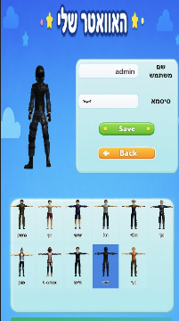
4. Submit the form. After successful signup, the app opens the groups page.

3. Logging In
Key screen elements — 'שם משתמש': username field; 'סיסמא': password field; 'התחברות': Log In button; 'הרשמה': link to the Sign Up screen for new users.
1. Open the login page.
2. Enter username and password.
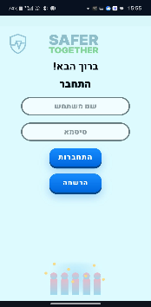
3. After successful login, the app opens the groups page.

4. Administrator: Creating a Group
Key screen elements — 'הקבוצות שלי': list of the user's groups; 'יצירת קבוצה חדשה' (Admin): opens the Create Group form; Join code field + 'שליחת בקשה': request to join an existing group; Avatar control: opens the Unity avatar editor; Location button: saves the user's Home Front Command alert area.
1. Log in as an administrator.
2. Open the create-group screen.
3. Enter the group name and submit.
4. The system creates the group and generates a join code.
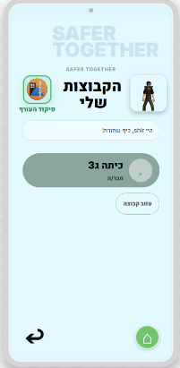
5. Share the join code with members who should join the group.

5. Member: Joining a Group
1. Log in as a user.
2. On the groups screen, enter the join code.
3. Submit the join request.
4. After administrator approval, the group appears in the user group list.

6. Administrator: Approving Join Requests
Key screen elements — Pencil icon (✏): edit group name (Admin); 'יצירת משחקון': create a new activity (Admin); 'משחקי הקבוצה': expand the group activity list (Admin); 'דוח סטטיסטיקות': open past event statistics (Admin); 'אזעקת תרגול': start a training drill (Admin); 'אזעקת אמת': start a real alarm session (Admin); Member cards: show avatar, name, and presence status; Home Front Command indicator: live external alert status.
1. Open the groups screen.
2. Review pending requests for groups owned by the administrator.
3. Approve the request. The member is added to the group membership list.
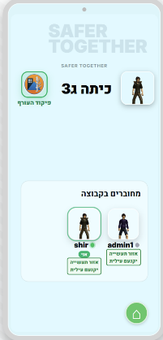

7. Saving Alert Location
1. The user allows browser location access.
2. The frontend sends the coordinates to the backend.
3. The backend maps the coordinates to a Home Front Command area.
4. The matched area is saved to the user profile so group alert status can be calculated.

8. Editing an Avatar
1. Open the groups/profile screen.
2. Press the avatar edit control.
3. The Unity avatar editor loads.
4. Choose an avatar and return to the web app.
5. The selected avatar is saved to the user profile and displayed on group member cards.

9. Administrator: Creating Activities
Administrators can create two activity types: trivia and mission. Trivia includes a title, questions, answer options, and a correct answer. Mission activities include selected Unity tasks such as puzzle, door-code memory, and missile dodge. Activities can be activated separately for real alarms and training alarms.

10. Starting a Training Alarm
Key screen elements — 'אני מוגן!': marks the current user as safe (all members); Group status panel: shows who has and has not confirmed safety; 'פתח פעילות לכולם': Admin override to unlock activities early; 'סיים אזעקה': ends the current alarm or drill (Admin only).
1. The administrator opens the group board.
2. The administrator starts a training alarm.
3. Members receive the emergency flow.
4. Each member marks safe.
5. Activities unlock when all members are safe or after administrator override.
6. Members complete activities.
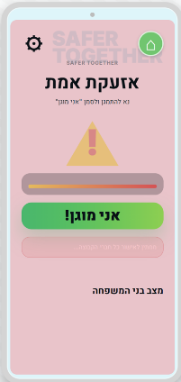
7. The administrator ends the alarm and reviews statistics.

11. Real Alarm Flow
1. A real alarm is raised by an administrator or by the Home Front Command integration when a verified live alert affects the group.
2. Members receive a push notification when supported.
3. Members open the emergency page and mark safe.
4. Activities unlock after the safety phase.
5. Members complete active real-mode activities.
6. The administrator monitors progress, ends the alarm, and reviews the results.

12. Emergency Screen
Key screen elements — 'אני מוגן!': marks the current user as safe (all members); Group status panel: shows who has and has not confirmed safety; 'פתח פעילות לכולם': Admin override to unlock activities early; 'סיים אזעקה': ends the current alarm or drill (Admin only).
The emergency screen shows the active group and the current alarm state. Members use it to mark themselves safe. Administrators use it to watch group progress and can unlock activities or end the alarm.
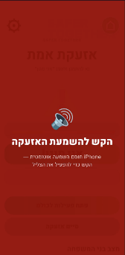
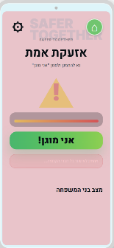

13. Game Page
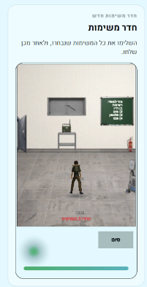
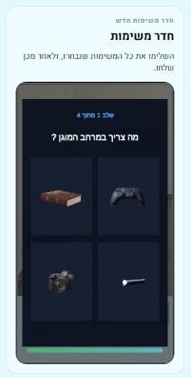
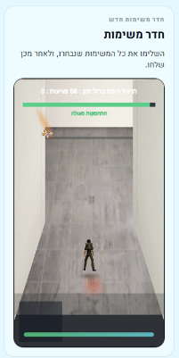
Key screen elements — Trivia mode: one question at a time with four options; Unity Mission Room: loads the selected mini-games (puzzle, door-code, missile-dodge); 'הפעל שליטה בהטיית הטלפון': requests motion-sensor permission for the missile game; do not close the page until the completion screen confirms submission.
The game page loads active activities for the current alarm mode. In trivia, the user answers one question at a time and the app records timing, correctness, and rotation when available. In the Unity mission room, the app sends selected tasks to Unity and Unity reports progress and completion back to the browser.

14. Statistics Page
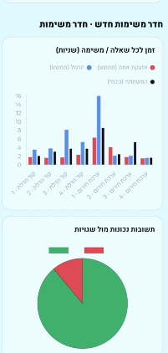
Key screen elements — Member selector: choose which member's results to review; Run selector: choose the specific alarm or drill session; Charts: display answer times, wrong attempts, and activity scores; 'צור ניתוח AI': optional non-clinical AI summary (requires Groq configuration); 'הורד PDF': downloads a PDF report; 'סיים אזעקה ושחרר את הקבוצה': ends a still-active event from this view.
The statistics page is available for administrators. The administrator selects a member and activity, reviews charts and result summaries, and may generate an AI situation summary for the selected member. The summary is intended to support follow-up decisions and is not a medical diagnosis.
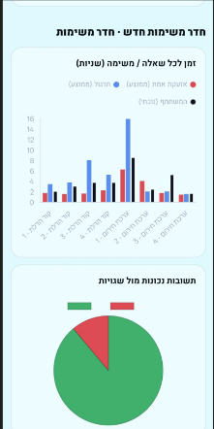
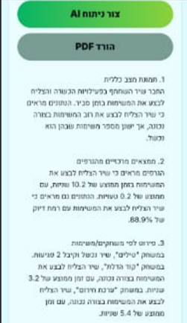

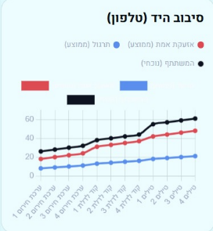
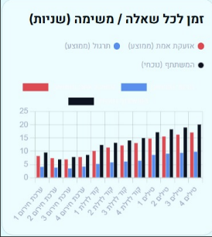
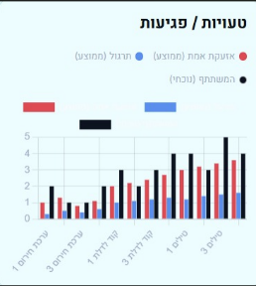

Appendix 2.2 - Maintenance Guide

Maintainer setup and operation

The following steps describe a clean installation. The required base tools are Git, Node.js 20 or newer, npm, and a current browser. Unity Hub and the exact Unity version listed in UnityClient/ProjectSettings/ProjectVersion.txt are needed only when rebuilding the WebGL projects. The already-built folders under SaferTogetherUI/unity are served as normal application assets.

Clone the repository and install the locked dependencies:

git clone https://github.com/barleibovich/SaferTogether.git
cd SaferTogether
npm install

If the Gateway package is maintained independently, enter Gateway and run npm install there as well. Do not remove package-lock.json during normal setup.

Create Gateway/.env. SUPABASE_URL is copied from Supabase Project Settings > API. SUPABASE_ANON_KEY is the anonymous project key used in the authenticated application flow. SUPABASE_SERVICE_ROLE_KEY is a private server key; it must never be committed or copied into SaferTogetherUI. PORT is optional and defaults to 5173. GROQ_API_KEY enables the written summary, and GROQ_MODEL may override the model configured in code. VAPID_PUBLIC_KEY and VAPID_PRIVATE_KEY form the Web Push pair; VAPID_SUBJECT is normally a mailto contact. OREF_ALERTS_URL, OREF_LOCATIONS_URL, and OREF_POLYGONS_URL are optional overrides. Restart Node after changing the file.

To create Supabase, sign in, choose New Project, select an organization and region, enter a project name and a strong database password, and wait for provisioning. Copy the project URL and keys into Gateway/.env. Open SQL Editor and execute the repository scripts in their dependency order: profiles and groups first, then group access policies, activities and metrics, alarms and the verified OREF function, presence, profile locations, avatars, and push subscriptions. Read the prerequisite comments in each script and check every result. In Authentication settings, add localhost and the deployed site to the permitted site and redirect URLs. Confirm in the policy view that RLS is enabled. Do not disable RLS to solve an authorization error.

From the repository root, run npm start. This starts Gateway/server.js and normally exposes http://localhost:5173/index.html. Keep the terminal open. Ctrl+C stops the process. If the address is already in use, stop the other process or change PORT. If configuration is missing, check the variable spelling and confirm that .env is inside Gateway. If a page loads but an operation fails, inspect the browser Network response and the server error, then follow the matching Gateway/routes file into Services.

Verify the installation with two isolated browser profiles. In the first, log in as administrator and create a group. In the second, create a regular member and request to join. Approve the request from the first profile and verify that both see the group but only the administrator sees management controls. Create and assign trivia, start training, confirm safety from both profiles, unlock the activity, complete it as the member, end the event, and select the new member/run in Statistics. Test push, geolocation, Unity, phone motion, PDF, and Groq separately because each depends on an external permission or service. tools/record-complete-demo.js automates the central two-account scenario and changes real test records.

For Vercel deployment, import the GitHub repository and keep the repository root as the project root. Add all required environment variables in the Vercel project settings, with separate values where necessary for Preview and Production. Deploy, add the final domain to the Supabase Authentication URLs, and repeat the smoke test on HTTPS. Check static HTML, /api routes, Unity assets, the service worker, notifications, and serverless logs. Keep the previous verified deployment available for rollback.

To rebuild Unity, open UnityClient through Unity Hub with the recorded editor and WebGL Build Support. Preserve the JavaScript bridge method names and JSON fields expected by app.js. Build the avatar editor and mission room into temporary output folders first. Serve them through Node rather than opening the generated HTML directly. Test canvas loading, avatar return, mission input, every selected game, completion callback, and database submission. Only then replace SaferTogetherUI/unity/avatar-editor or mission-room. Do not commit Library, Temp, Logs, or other Unity caches.

Database changes should be delivered as a new reviewed SQL script. Test the script in a development project, back up affected data, verify RLS for an administrator, a valid member, and an unrelated user, and keep compatibility with the deployed client when possible. A new HTTP endpoint belongs in the relevant route module, delegates its rules to a service, validates input, checks authentication and group authorization, returns stable JSON, and is exposed through the matching frontend gateway.

For routine maintenance, monitor Vercel function errors and Supabase database/authentication health. Review dependency advisories in a branch and inspect changes to package-lock.json. Before a release, repeat the two-account flow and check OREF parsing, expired push cleanup, both Unity bridges, activity results, statistics, PDF export, and the service worker. Git stores source and SQL definitions but not live database rows or secrets, so enable suitable Supabase backups, test restoration in a non-production project, and keep a separate secret-rotation procedure.

1. System Requirements for Local Development
Node.js 20 or newer.
A Supabase project.
Unity Editor for rebuilding WebGL modules.
A modern browser that supports Service Workers for push testing.

2. Repository Structure
Folder | Purpose
Gateway | Node.js gateway and API route handlers.
Services | Business logic and external integrations.
SaferTogetherUI | Static frontend, CSS, JavaScript modules, audio, service worker, and WebGL builds.
UnityClient | Unity source project.
supabase | SQL scripts for database schema and policies.
api | Vercel serverless entry point.

3. Local Installation
1. Clone or open the project folder from the GitHub repository.
2. Install Node dependencies from the project root.
npm install
3. Configure environment variables in Gateway/.env or in the process environment.
4. Run the required SQL files in Supabase.
5. Start the gateway.
npm start
6. Open the local URL printed by the server, usually http://localhost:5173

4. Environment Variables

Variable | Description | How to Obtain | Required?
SUPABASE_URL | Project API URL for all database and auth calls. | Supabase Dashboard → Settings → API → Project URL | Required
SUPABASE_ANON_KEY | Public anonymous key for authenticated client requests. | Supabase Dashboard → Settings → API → anon key | Required
SUPABASE_SERVICE_ROLE_KEY | Full-access server key — never expose to the browser. | Supabase Dashboard → Settings → API → service_role key | Required
PORT | Local port the gateway listens on (defaults to 5173). | Any free port number | Optional
VAPID_PUBLIC_KEY | Web Push public key sent to browsers for subscription. | Run: npx web-push generate-vapid-keys | Required for push
VAPID_PRIVATE_KEY | Web Push private key — keep secret, never commit. | Same command as VAPID_PUBLIC_KEY | Required for push
VAPID_SUBJECT | Contact identity for the push sender. | e.g. mailto:your@email.com | Required for push
GROQ_API_KEY | API key for the optional AI situation summary. | https://console.groq.com → API Keys | Optional
GROQ_MODEL | Groq model name (e.g. llama-3.3-70b-versatile). | See Groq model documentation | Optional
OREF_ALERTS_URL | Override for the Home Front Command alerts endpoint. | Leave empty to use the built-in production default | Optional
OREF_LOCATIONS_URL | Override for the locations metadata endpoint. | Leave empty to use the built-in production default | Optional
OREF_POLYGONS_URL | Override for the polygon area file endpoint. | Leave empty to use the built-in production default | Optional

5. Database Setup Procedure
1. Create a Supabase project.
2. Configure Supabase Auth.
3. Apply base profile and group scripts from the project history if needed.
4. Run group_access_policies.sql.
5. Run profile_avatars.sql.
6. Run profile_locations.sql.
7. Run presence.sql.
8. Run group_activities.sql.
9. Run activity_metrics.sql.
10. Run group_alarms.sql.
11. Run group_alarm_oref_raise.sql.
12. Run push_subscriptions.sql.
13. Test signup, group creation, activity creation, alarm start, safe marking, and statistics loading.

6. Local Server Operation
Running npm start starts Gateway/server.js. The server reads configuration, listens on the configured port, dispatches API calls, and serves the static frontend. If the port is already in use, set the PORT environment variable or stop the other server.

7. Deployment Operation
The project includes vercel.json. Static frontend files are served from SaferTogetherUI. API paths are rewritten to /api, and api/index.js passes requests to the gateway handler. Unity WebGL gzip files receive the correct content encoding and content type headers. Before deployment, configure all required environment variables in Vercel.

8. Monitoring and Backup
Monitor API errors from the Node.js gateway.
Monitor Supabase database errors and RLS denials.
Monitor push notification failures and stale endpoints.
Monitor Home Front Command fetch failures and fallback behavior.
Monitor Unity WebGL load failures.
Monitor AI provider errors or missing configuration.
Define a transparent retention policy for group membership, alarms, activity results, behavioral telemetry, and any stored summaries.

9. Regular Maintenance Procedures
Review Supabase schema and policies after each feature change.
Rotate VAPID and AI provider keys if exposed.
Rebuild Unity WebGL after Unity source changes.
Test service worker notification behavior on mobile browsers.
Verify Home Front Command status endpoint and fallback behavior.
Check that expired push endpoints are removed.
Run manual alarm drills after deployment.
Keep Node.js dependencies updated.

10. Unity Build Maintenance
1. Open the Unity project in UnityClient.
2. Build the avatar editor to SaferTogetherUI/unity/avatar-editor.
3. Build the mission room to SaferTogetherUI/unity/mission-room.
4. Confirm that .loader.js, .data.gz, .framework.js.gz, and .wasm.gz files exist.
5. Run the web app and verify that Unity loads in the browser.

11. Verification and Testing Process
Testing focuses on authentication correctness, group membership correctness, alarm lifecycle correctness, activity result persistence, statistics correctness, Unity-to-web bridge reliability, push notification registration and delivery, Home Front Command status handling, and mobile sensor fallbacks.
Test case | Expected result
Signup and login | A new profile is created, tokens are returned, and /api/auth/profile returns the profile.
Admin creates group | A group row is created, join code exists, and admin is inserted as a member.
Member requests join | Join request is created and appears to the admin.
Admin approves join | Member becomes visible in the group board.
Training alarm starts | Active alarm exists with mode training; members see emergency screen state.
Member marks safe | Safe row is inserted; when all users are safe the alarm unlocks.
Trivia result | Result row is created with item metrics and approved status.
Mission result | Unity result JSON is received, converted into metric items, and stored.
Statistics page | Admin receives members, activities, aggregate metrics, and latest results.
Push subscription | Device subscription is saved and receives alarm notification.

12. Main API Endpoints Authentication
POST /api/auth/signup
→ Creates a new account. Body: { username, password, role }. Returns tokens + profile. Fails if username taken.
POST /api/auth/login
→ Authenticates a user. Body: { username, password }. Returns access + refresh tokens and profile.
POST /api/auth/refresh
→ Exchanges a valid refresh token for a new access token. Called automatically on token expiry.
POST /api/auth/logout
→ Invalidates the session and clears the refresh token.
GET /api/auth/profile
→ Returns the authenticated user's profile: role, avatar data, and saved alert location.
PATCH /api/auth/profile
→ Updates profile fields (e.g. avatar image data).
PATCH /api/auth/credentials
→ Changes the username or password for the current user.
PATCH /api/auth/location
→ Saves the user's alert area by converting browser geolocation coordinates to a Home Front Command region.

Groups
GET /api/groups
→ Returns all groups the authenticated user belongs to (as admin or member).
POST /api/groups
→ Creates a new group. The caller becomes the administrator. Returns the group + generated join code.
PATCH /api/groups/:groupId
→ Updates group name or description. Administrator only.
DELETE /api/groups/:groupId
→ Deletes the group and all associated data. Administrator only.
POST /api/groups/join-requests
→ Submits a join request using a group join code. Creates a pending request for the administrator.
PATCH /api/groups/:groupId/join-requests/:requestId
→ Approves or denies a pending join request. Administrator only.
DELETE /api/groups/:groupId/members/me
→ Removes the current user from the group (leave action). Not available to the group administrator.

Drills and alarms
POST /api/groups/:groupId/drill
→ Starts a training drill for the group.
DELETE /api/groups/:groupId/drill
→ Ends the active drill and clears its state.
POST /api/groups/:groupId/drill/safe
→ Records the current user as safe in the active drill.
GET /api/groups/:groupId/drill/status
→ Returns drill state: active flag, who confirmed safety, whether activities are unlocked.
POST /api/groups/:groupId/alarm
→ Starts a real alarm session manually. Administrator only.
POST /api/groups/:groupId/alarm/oref
→ Starts a real alarm after the server verifies a live Home Front Command alert affects the group's location.
GET /api/groups/:groupId/alarm
→ Returns the current alarm state: safety confirmations, unlock flag, and mode (real / training).
DELETE /api/groups/:groupId/alarm
→ Ends the active alarm and records the end time.
POST /api/groups/:groupId/alarm/safe
→ Records the current user as safe in the active alarm.
POST /api/groups/:groupId/alarm/unlock
→ Administrator override: unlocks activities before all members confirm.
POST /api/groups/:groupId/alarm/progress
→ Updates live alarm progress used by the group board for real-time monitoring.

Activities and statistics
GET /api/groups/:groupId/activities
→ Returns all activities defined for the group.
POST /api/groups/:groupId/activities
→ Creates a new trivia or Unity mission activity. Administrator only.
DELETE /api/groups/:groupId/activities/:activityId
→ Deletes an activity and its stored results. Administrator only.
POST /api/groups/:groupId/activities/:activityId/activate
→ Assigns an activity to a specific alarm mode (real or training). Administrator only.
DELETE /api/groups/:groupId/activity-activations/:mode/:activityId
→ Removes an activity from the specified alarm mode. Administrator only.
GET /api/groups/:groupId/active-activities?mode=real
→ Returns activities currently assigned to the given mode. Used by the game page to load content.
GET /api/groups/:groupId/activity-results
→ Returns stored results for completed activities in the group.
POST /api/groups/:groupId/activity-results
→ Submits a completed activity result with timing, correctness, and game metric payload.
PATCH /api/groups/:groupId/activity-results/:resultId
→ Updates a result record (e.g. marks it as reviewed).
GET /api/groups/:groupId/statistics
→ Returns aggregated statistics for all members and activities, used by the statistics page.
POST /api/groups/:groupId/stats-summary
→ Requests a non-clinical AI summary for a specified member/activity run. Requires Groq key.

Home Front Command, presence, and push
GET /api/oref/groups/:groupId/status
→ Checks the current Home Front Command alert status for the group's saved location.
POST /api/presence
→ Records a heartbeat for the current user, used for presence tracking on the group board.
GET /api/push/config
→ Returns the VAPID public key needed for the browser to create a Web Push subscription.
POST /api/push/subscriptions
→ Stores a Web Push subscription for the current user's device.
DELETE /api/push/subscriptions
→ Removes a push subscription (used on logout or permission revocation).

13. Main Data Entities
Entity | Main fields / purpose
Profile | User ID, username, role, avatar data, alert location, presence heartbeat.
Group | Group ID, name, description, creator, join code, drill state.
Membership | Group ID, user ID, member username.
Join request | Group ID, user ID, requested username, status.
Alarm | Alarm ID, group ID, mode, status, started by, started at, unlocked flag, ended at.
Activity | Activity ID, group ID, type, title, payload.
Activity result | Result ID, group ID, activity ID, user ID, mode, status, payload, review fields.
Metric aggregate | Group ID, activity ID, metric type, mode, item index, average value.
Push subscription | User ID, endpoint, subscription JSON, user agent.

14. Screen Reference
For full screen-by-screen descriptions with annotated screenshots, see Appendix 2.1 — User Guide. From a maintenance perspective, each screen is served as a static HTML file under SaferTogetherUI/ and loads its data through the API routes listed in Section 12. No screen-specific server configuration is required beyond the environment variables in Section 4.

